**DAVIDSEN CELL PHONE AND ELECTRONIC DEVICE POLICY**

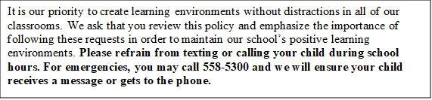

During school hours **cell phones, earbuds**, and **other electronic devices** are to be used under the supervision of school staff members for educational purposes only. Cell phones will be turned off and stored in wall pockets each period unless being used instructionally and supervised by the classroom teacher.

Students must comply with the directives of school/district staff regarding when and where electronic devices may be used. Cell phone conversations during the school day are prohibited unless under the supervision of staff/school personnel. Failure to comply with staff directives may result in the following student consequences:

* **First Offense:** Verbal warning issued to student.
* **Second Offense:** The device may be confiscated by staff members, labeled, and secured in classroom. The phone will be returned at the end of the period and parents contacted by teacher via phone or email.
* **Third Offense:** The **s**tudent who committed the violation will deliver his/her phone to be locked up in the Student Affairs Office. The phone will be returned to the student at the end of the school day and a parent may be contacted.
* **Fourth Offense:** The student who committed the violation will deliver his/her phone to be locked up in the Student Affairs Office. Device may require parent pick up and an administrator will contact parent.
* Continuous cell phone violations may result in further disciplinary actions for willful disobedience and may result in loss of privileges to include field trips, incentives, and after-school events.

**As stated in the HCPS Student Code of Conduct, school staff/district personnel will not be held responsible if a device is lost, stolen or misplaced, including those that have been confiscated. Devices cannot be charged at school, unless specific permission is granted.**

**Cell phone violations start over every 9 weeks.**